**Gap Analysis Report (Jan 2019- June 2019)**

**Department of XXXXX**

**DBCE/2018-2019/Ver1.0**

**Guest Lecture Report**

|  |  |
| --- | --- |
| **Activity Name** | Guest Lecture on  “Mix Proportioning of Concrete with and without admixture” |
| **Activity Date** | 7th September 2018 |
| **Activity Venue** | SE Civil Classroom |
| **Objective of Activity** | To make students understand purpose and significance of mix proportioning of concrete. |
| **CO/PO/PSO** |  |
| **Justification** | Mix design is a very important concept for a civil engineer. As the students do not have a practical application of the same in the curriculum it is important to demonstrate the process of mix design and casting of concrete and also to relate the theoretical knowledge to real life application. |
| **Activity Coordinators** | Prof. Starina Dias |
| **Speaker** | Mr. Vikrant Dessai, Technical Officer, Ultratech Cements |
| **Summary** | The lecture started with the introduction to Is 10262 which covers the standards to be considered for mix design. Later the speaker explained the mix design procedure with an example in detail. Students also were asked to solve the example. In the post lunch session Mr. Vikrant performed tests to demonstrate the workability of concrete mix designed by the students in the morning session. |
| **Attendees** | Students of Second Year Civil Engineering (67/100) and Faculty member (1) |
| **Outcomes and Takeaways** | The students could understand the detailed procedure of mix design according to the procedure prescribed by the Indian Standard Code. (IS 10262) |

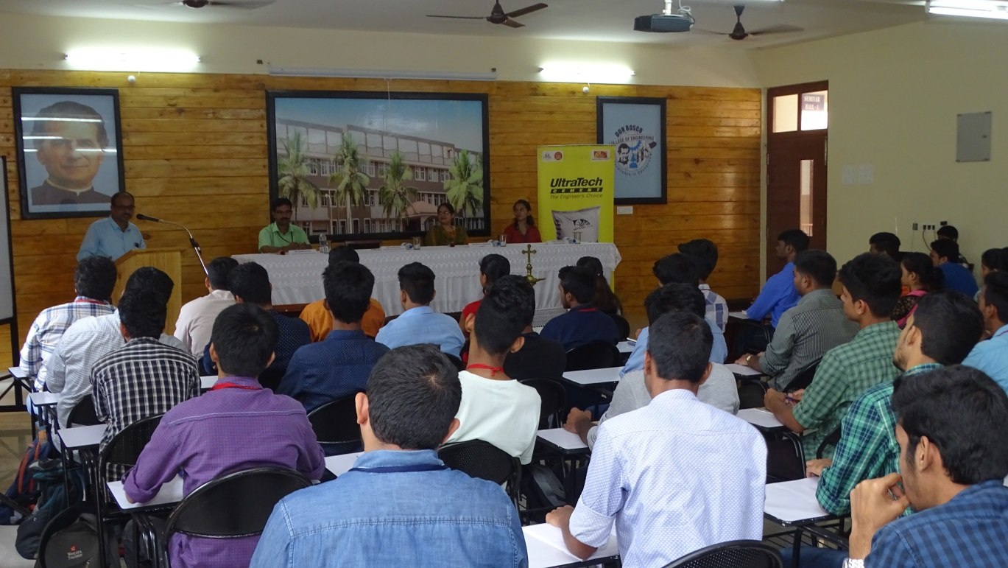

**Instructor In-Charge**  **Head of Department**

[Department Name]